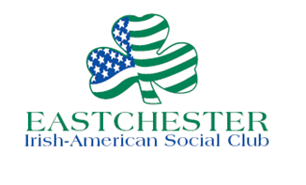

“GREEN LINE” BUSINESS SPONSOR MAC LEE SULLIVAN OF EASTCHESTER URGENT CARE
NAMED FOR EASTCHESTER’S ANNUAL ST. PAT’S DAY PARADE
13th Annual Parade Set for March 12

March 7, 2017 Contact:
PHOTO ATTACHED, CAPTION BELOW Connie M. Cullen, 914-980-0034

FOR IMMEDIATE RELEASE

EASTCHESTER —The Eastchester Irish American Social Club (EIASC) has named Dr. Mac Lee Sullivan of Eastchester Urgent Care and Fitness Recovery as “Green Line Sponsor” for the EIASC’s 2017 Eastchester St. Patrick’s Day Parade on March 12.

The green line will be painted on Friday, March 10 at about 11 pm, along the route including White Plains Road (Route 22), to help build community support for the parade’s celebration of Irish culture.

Grand Marshal for the parade is Sean Mackin, Eastchester resident, and owner of Preferred Mechanical Inc. and Preferred Sprinkler Corp., and Parade Honorees are Nancy Heffernan, Caroline O’Connell and Margaret Reynolds Stapleton, all of Eastchester,

The parade, sponsored by EIASC, will take place on Sunday Mar. 12, 2017. It will start at 3 pm at Immaculate Conception Church in Tuckahoe and head north on Route 22, following the green line, to Lake Isle Park in Eastchester.

EIASC, a civic organization dedicated to furthering the importance of Irish culture in the community, was founded in 1966. It consists of members from Eastchester, Tuckahoe, Bronxville and Crestwood. For more information, please visit eastchesterirish.org.

PHOTO: ATTACHED
PHOTO CAPTION: “Green Line” Sponsor Dr. Mac Lee Sullivan, second from right, and his staff at Eastchester Urgent Care and Fitness Recovery prepare for the painting of the green line on White Plains Road in Eastchester to help build community spirit for the Eastchester Irish-American Social Club’s 13th Annual St. Patrick’s Parade on Sunday March 12.

